1. 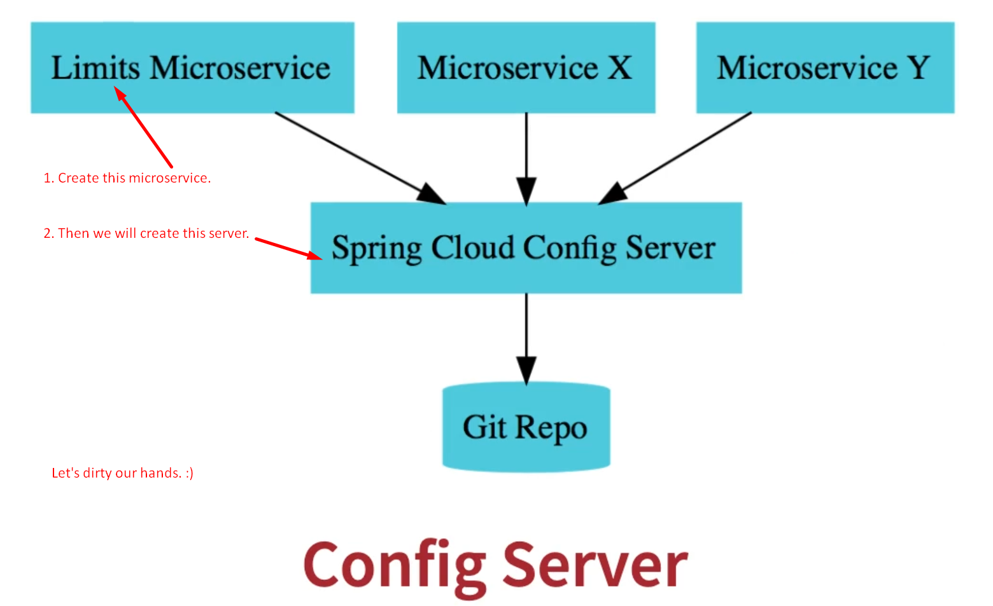
2. Let’s create Limit Microservice.
3. Now import:  
   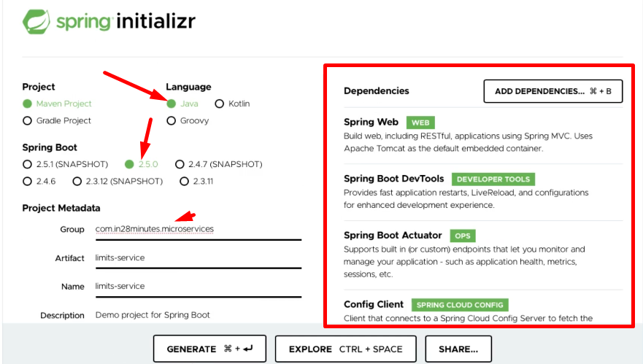c  
   **Config Client Dependency**: To connect with “Spring Cloud Config Server”.
4. 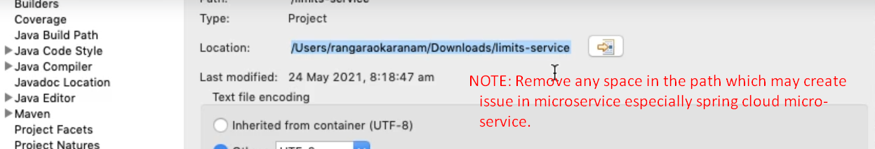
5. 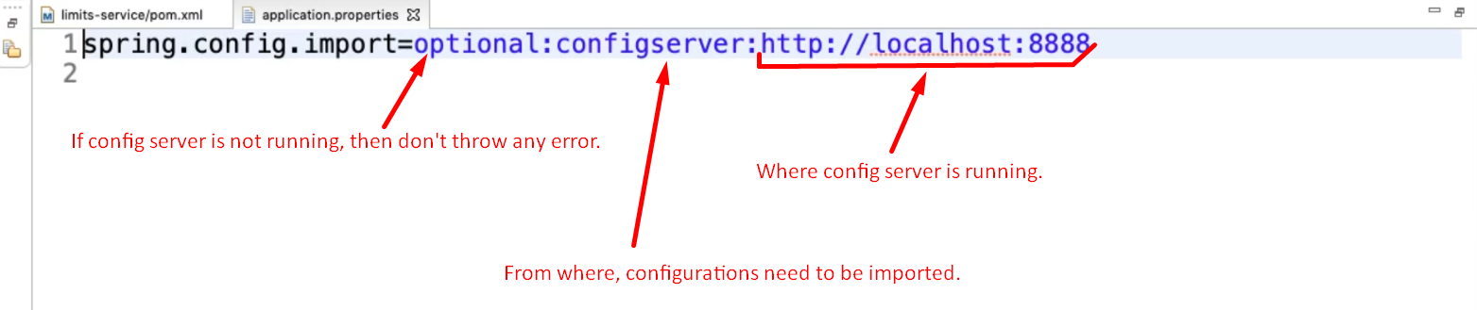**optional**: Config server connection is optional.  
   In latest Spring Boot version, your app will not start up if you have spring-boot-starter-config dependency but not the above configuration.